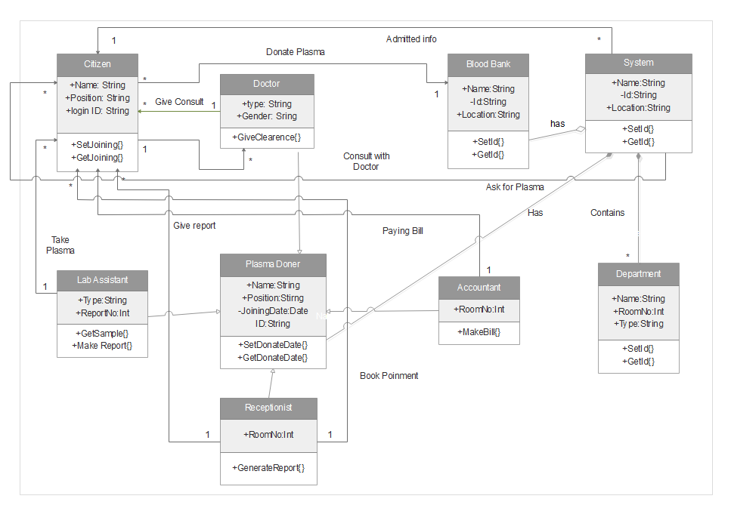

Citizen

+Name: String

+Position: String

+login ID: String

+SetJoining{}

+GetJoining{}

Doctor

+type: String

+Gender: Sring

+GiveClearence{}

Give Consult

Lab Assistant

+Type:String

+ReportNo:Int

+GetSample{}

+Make Report{}

Receptionist

+RoomNo:Int

+GenerateReport{}

Doner

+Name:String

+Position:Stirng

-JoiningDate:Date

ID:String

+SetDonateDate{}

+GetDonateDate{}

\*

1

Consult with Doctor

\*

1

\*

1

Take Test

1

\*

Give report

System

+Name:String

-Id:String

+Location:String

+SetId{}

+GetId{}

Blood Bank

+Name:String

-Id:String

+Location:String

+SetId{}

+GetId{}

Accountant

+RoomNo:Int

+MakeBill{}

Department

+Name:String

+RoomNo:Int

+Type:String

+SetId{}

+GetId{}

has

Donate Blood

\*

1

Paying Bill

1

\*

Name

Contains

\*

Name

Has

Admitted info

\*

1

Created by Unlicensed Version

Created by Unlicensed Version

Created by Unlicensed Version

Created by Unlicensed Version

Created by Unlicensed Version

Created by Unlicensed Version

Created by Unlicensed Version

Created by Unlicensed Version

Created by Unlicensed Version